Review

Entities

DAL Context class

Web.config

Menus

BLL Controller

List

Get

Add

Update

Delete

PL

Web Application

Web forms

ODS

Multi- record Controls

GridView

ListView

Traversing

Accessing individual fields

Entities will be SINGULAR!!!! Because a class is a program defining data type

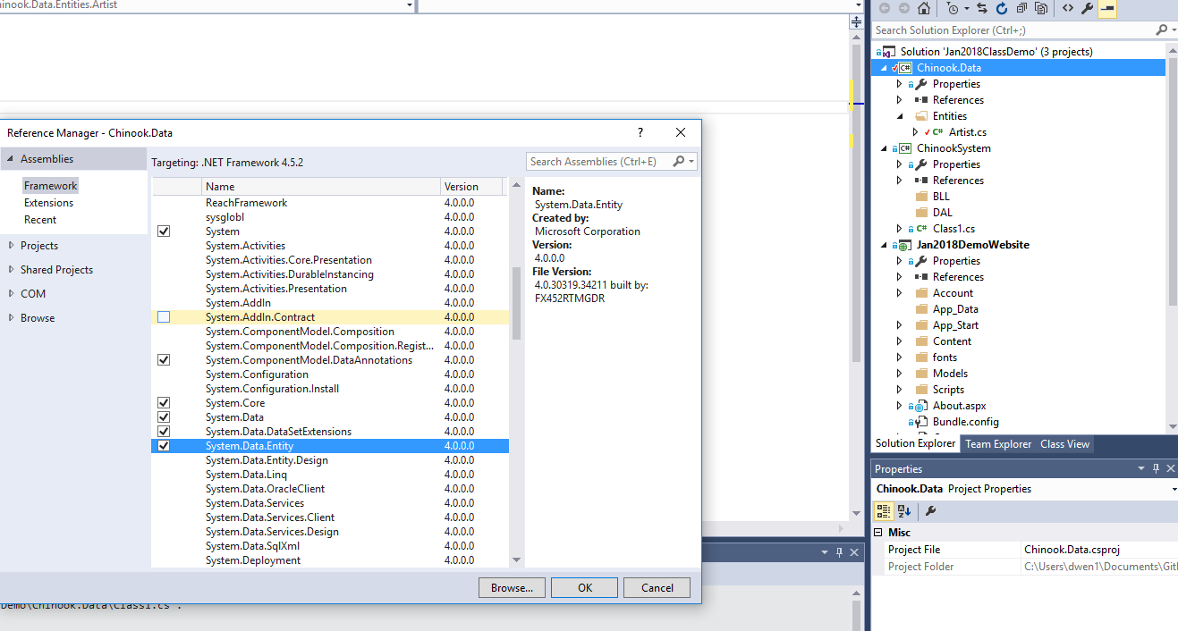

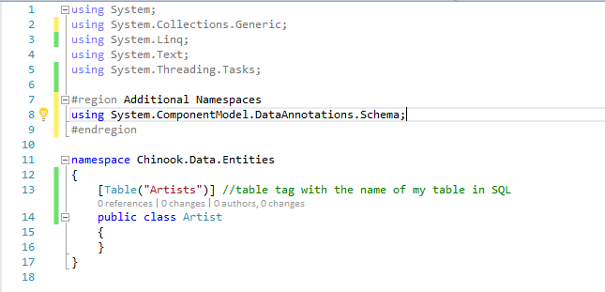

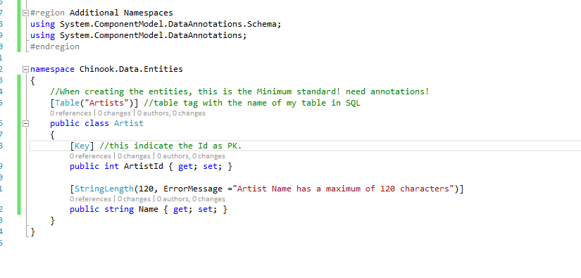

We can set up Entities that have a virtual mapping of the datebase.

We need to set something up between entities, we want to know who is the Parent, who is the child.

This is how we bring it in.

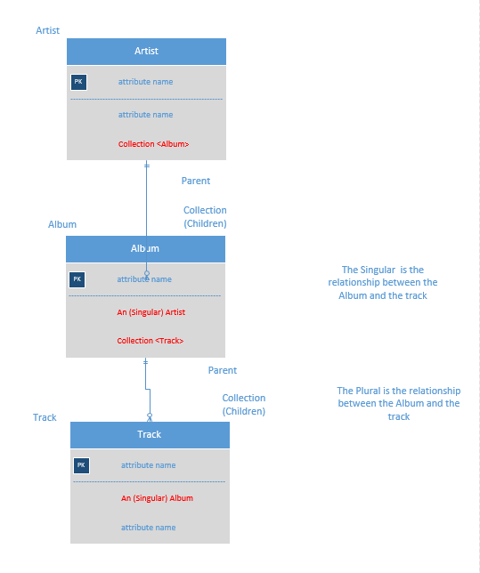

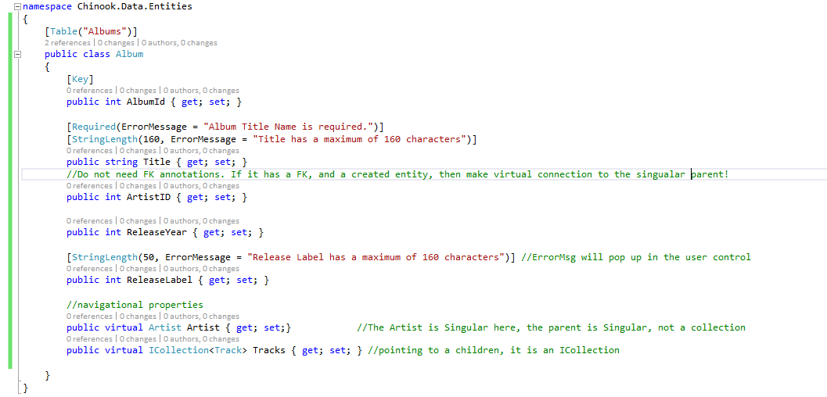

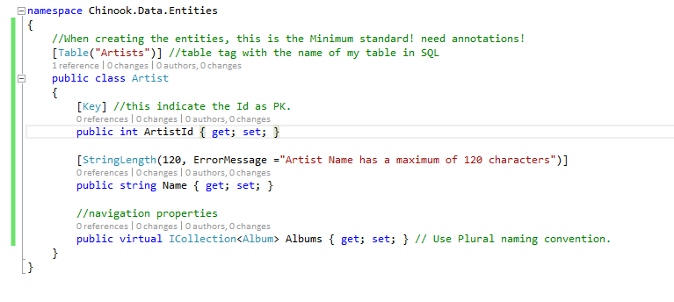

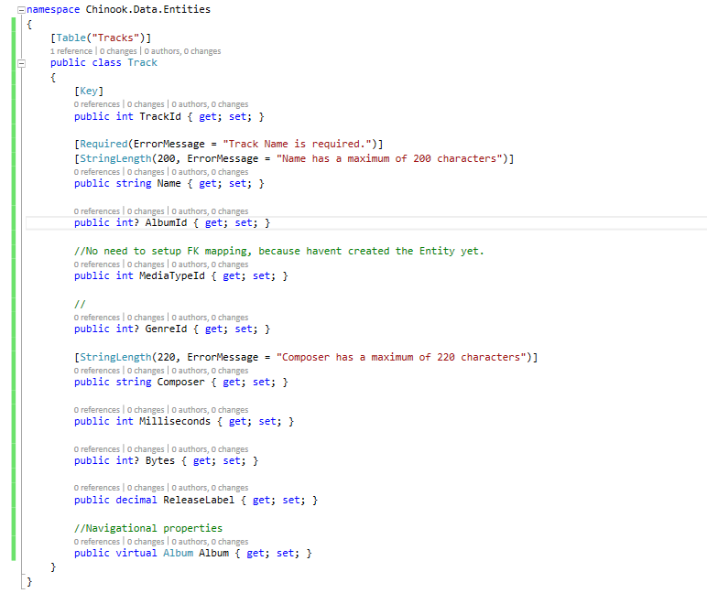

Next step is the context class that interact with the entity framework.

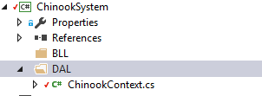

Lets make sure the enetity framework is available, Right clikc on the ChinnokSystem



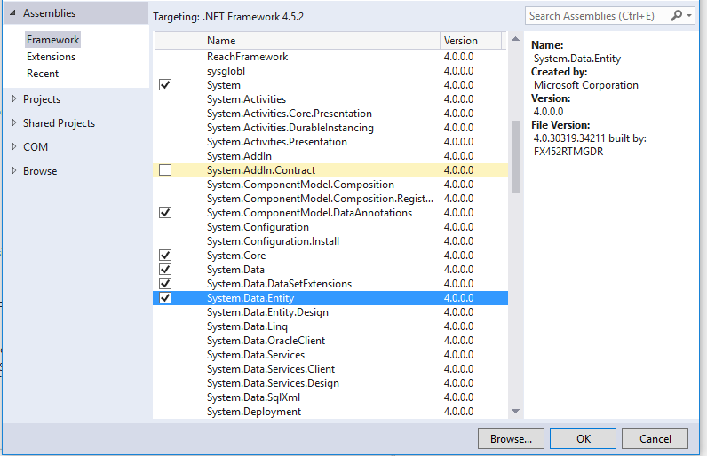

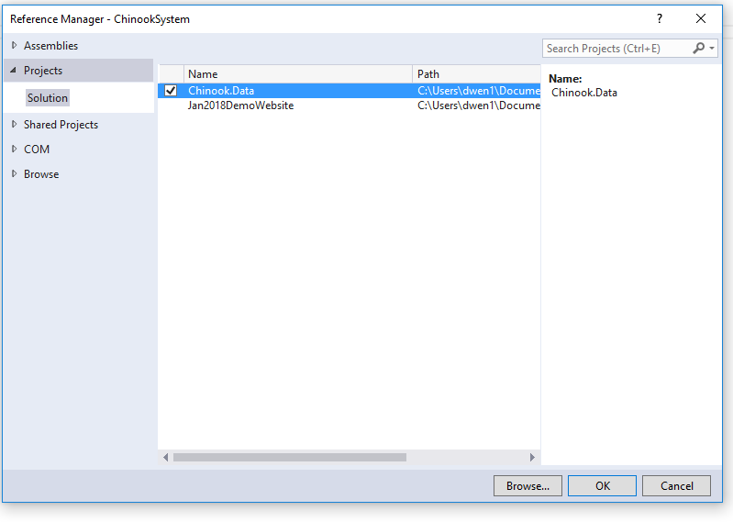

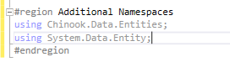

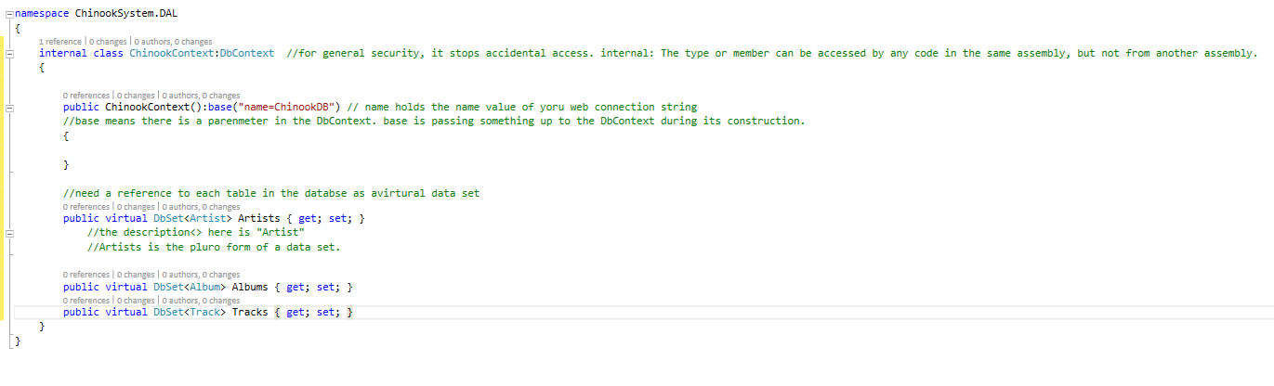

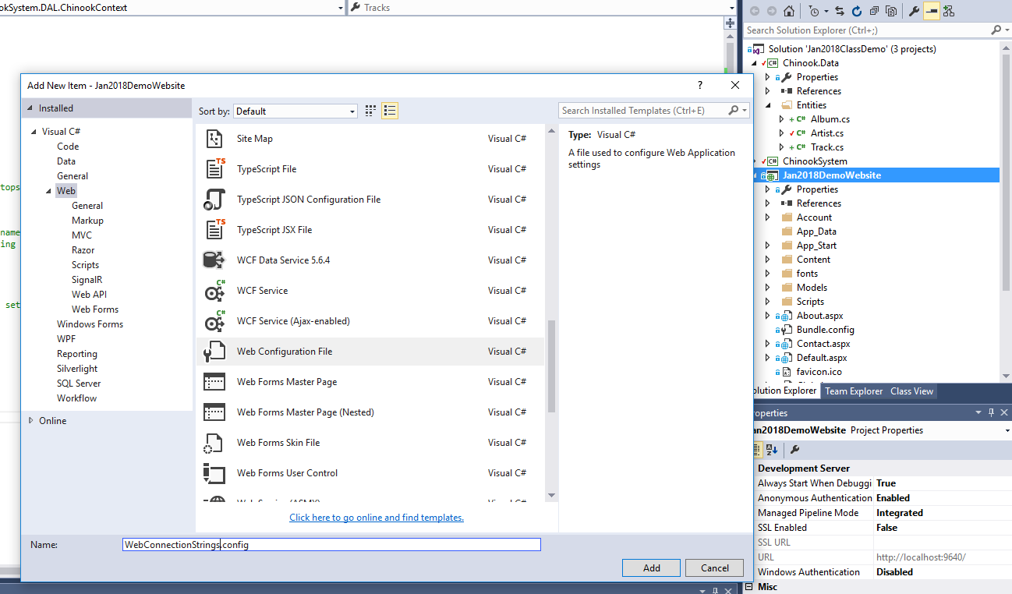

When we get to security, we will modify the default connection sting.

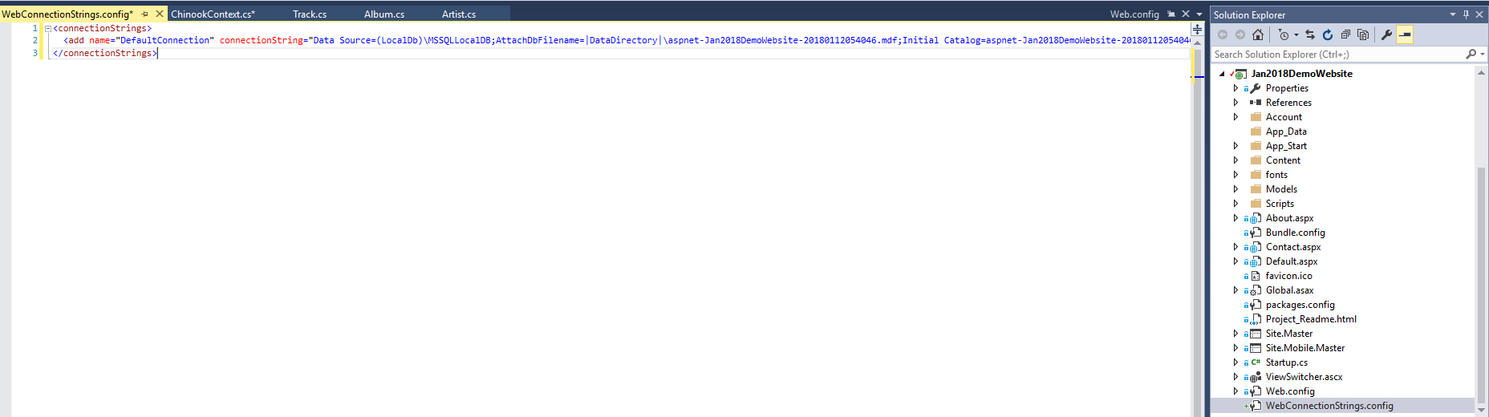

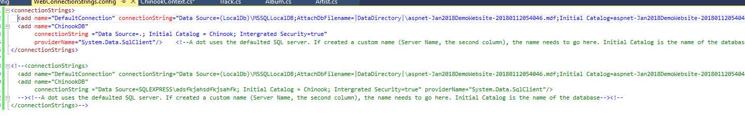



<entityFramework>

<contexts>

<context disableDatabaseInitialization="true" type ="ChinookSystem.DAL.ChinookContext, ChinookSystem"></context> <!--true means do not initialize the database for me, instead blow up, let me fix it. ChinookSystem is the ASSEMBLY Name.Found in ChinookSystem's Properties!-->

</contexts>

Where to get the Assembly name.

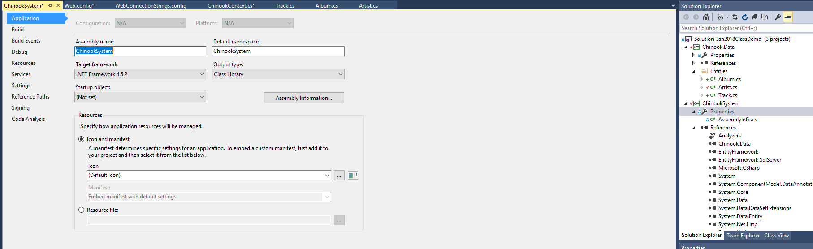

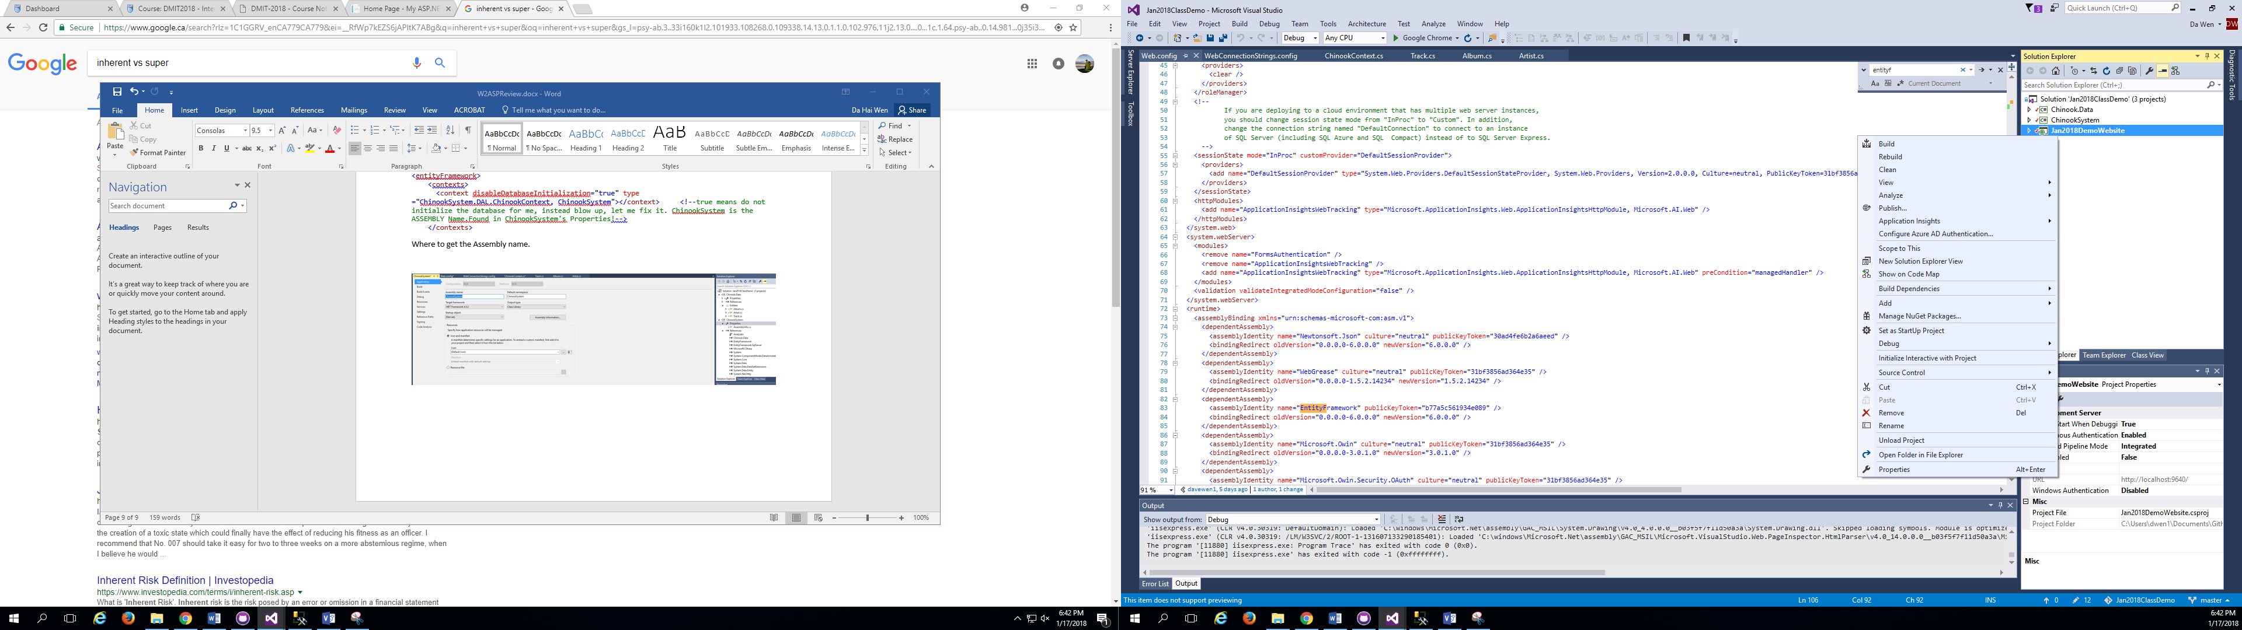

Sometimes right click -> rebuild might fix the problems

**BE Careful with Bootstrap 4.0.0**

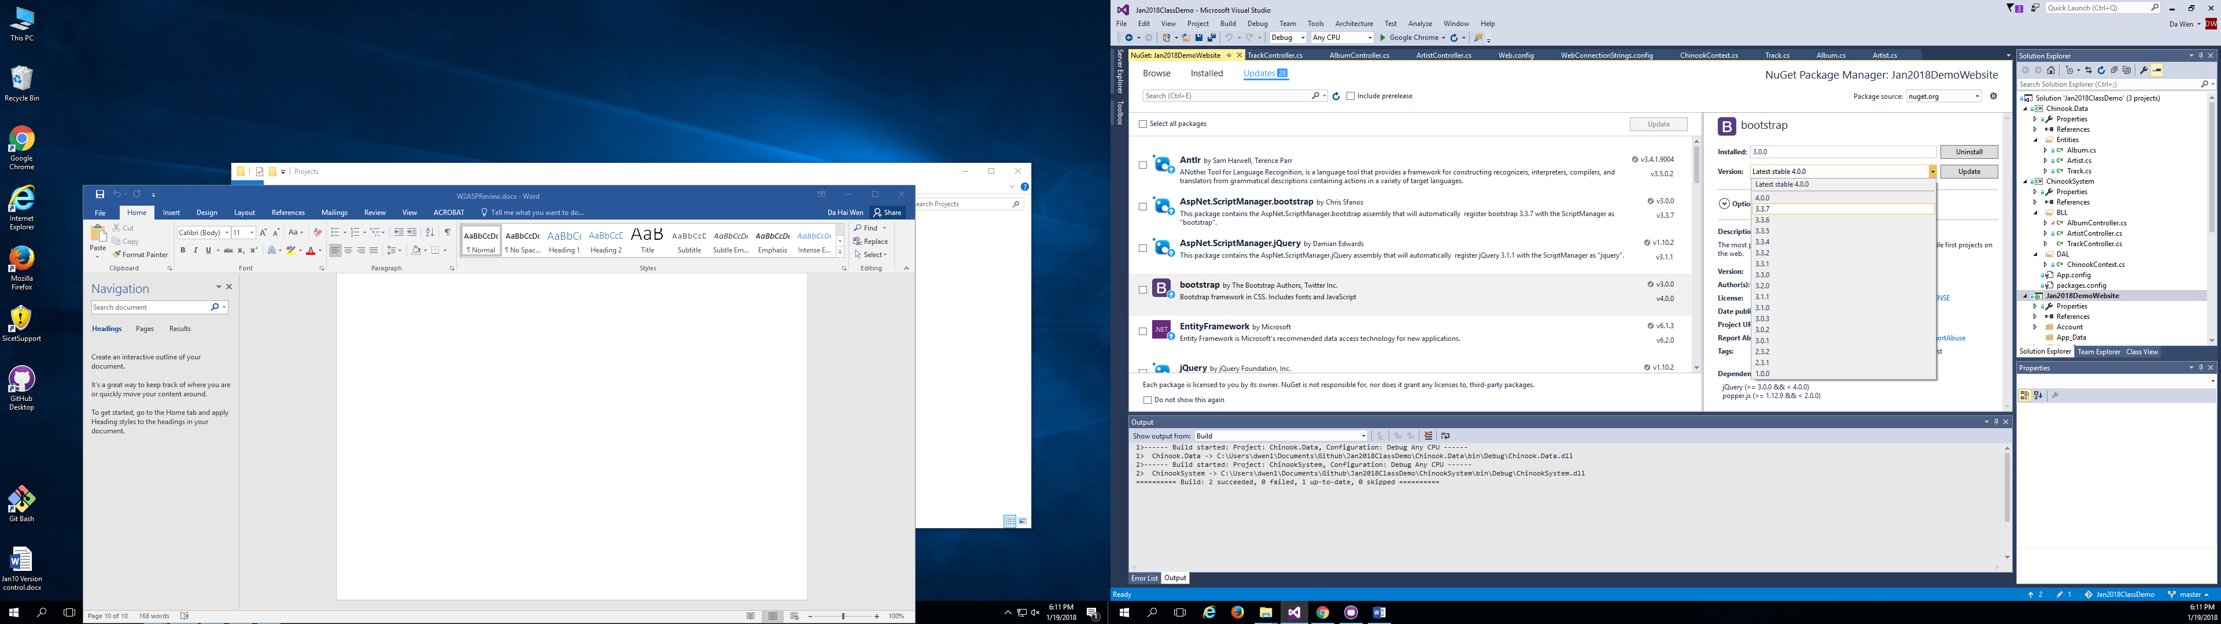

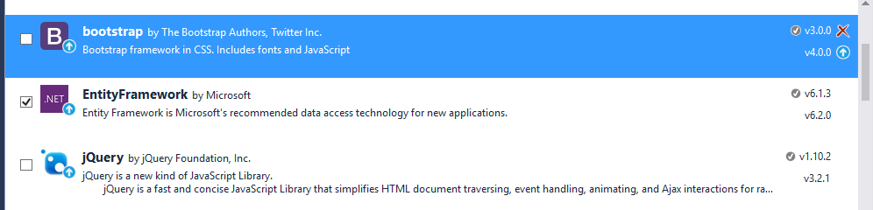

**Restart**

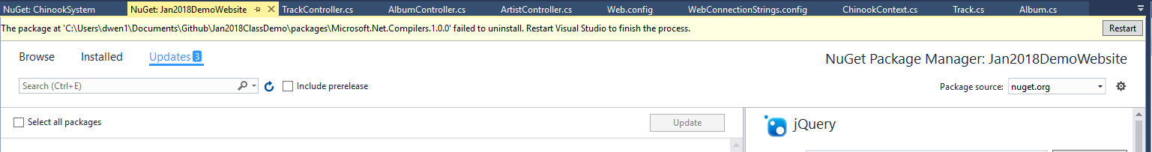

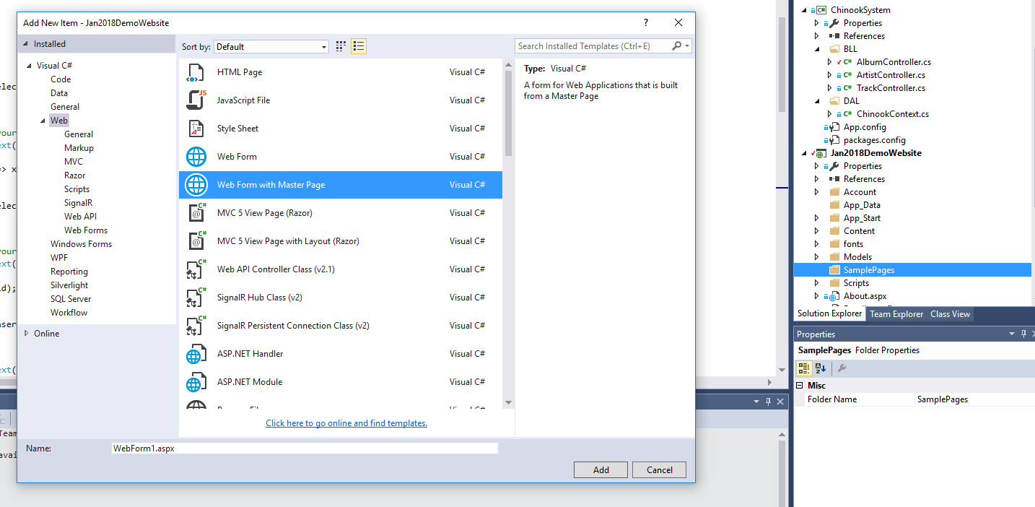

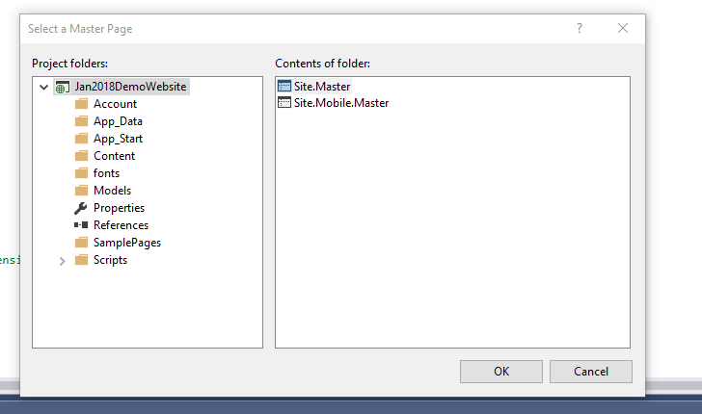

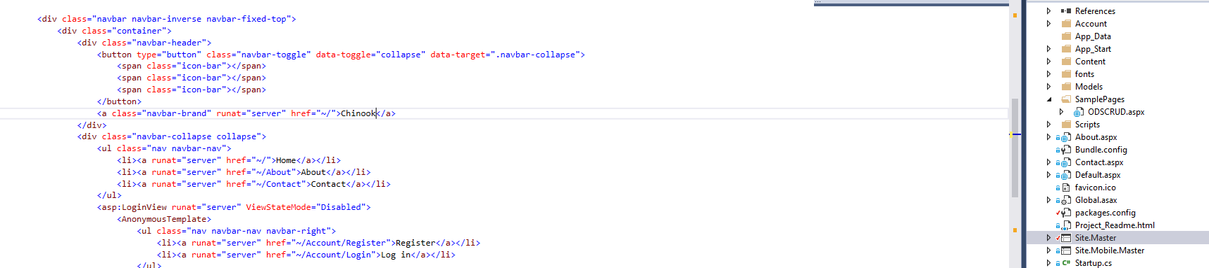

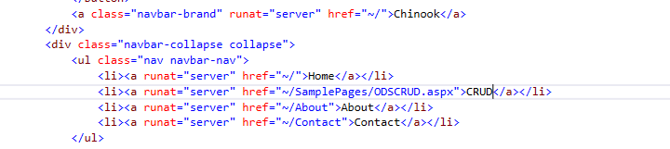

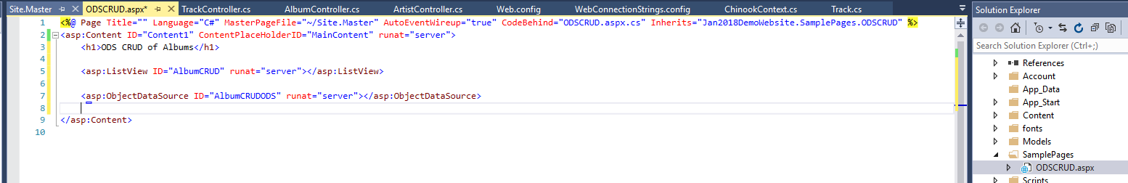

**Set references**

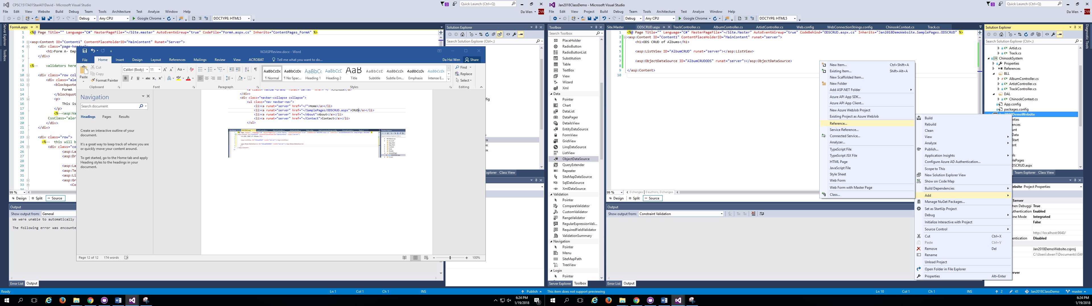

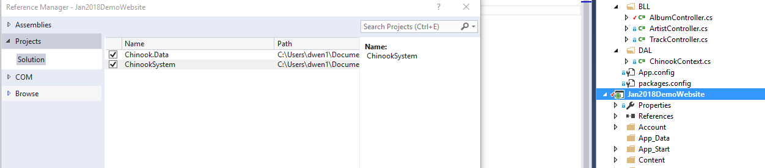

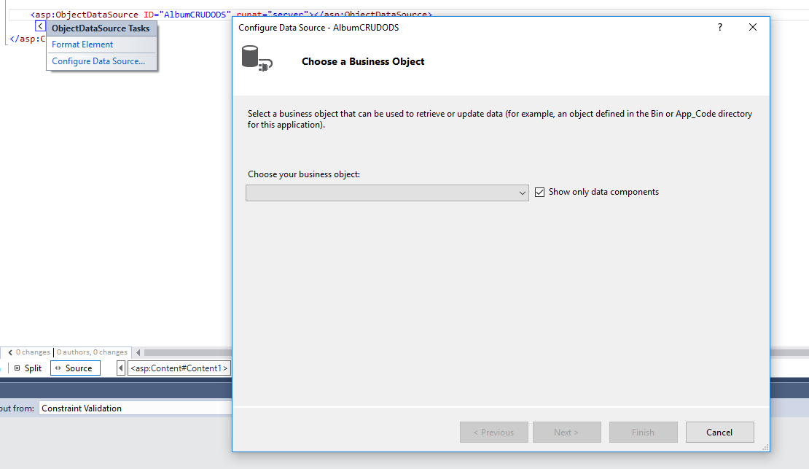

**If we don’t see bll methods,**

1. **Did not build after changing controller class**
2. **Did not set reference**
3. **Did not put “public” on the controller class.**

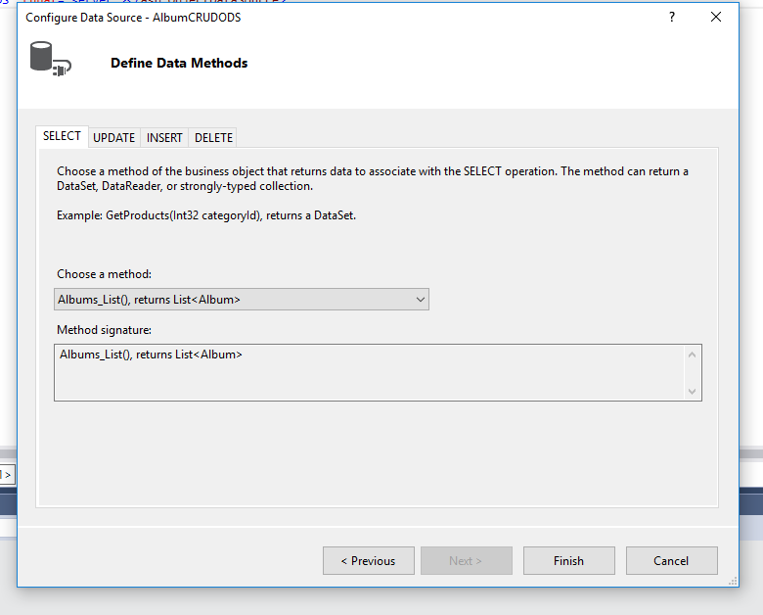

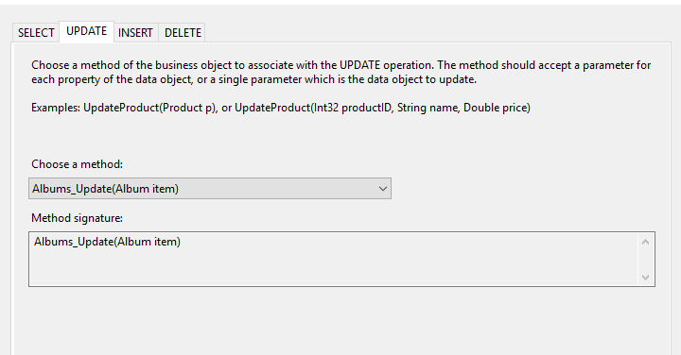

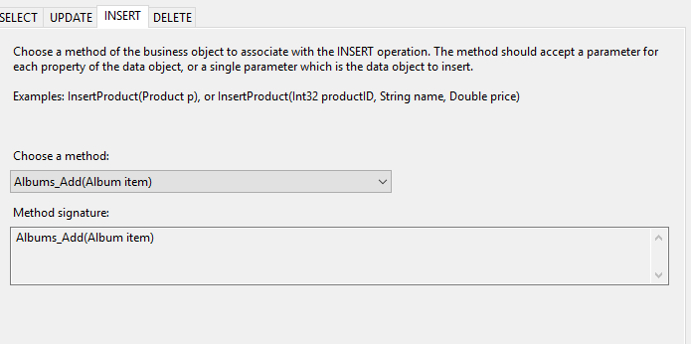

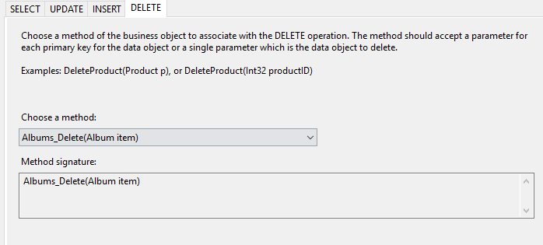

**IMPORTANT The Name must match the entity Name**

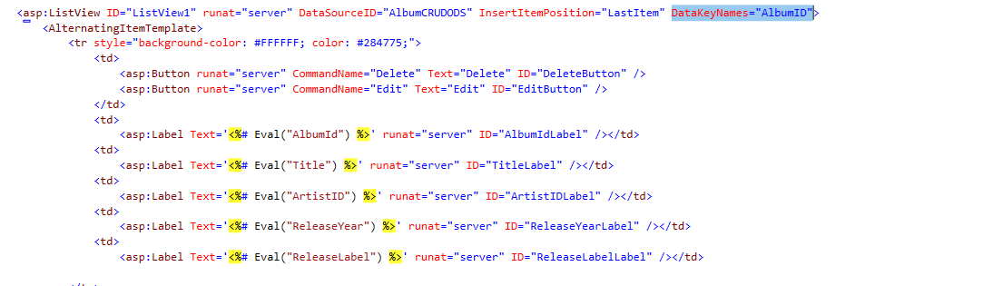

**When in doubt, check WebConnectionStrings!**

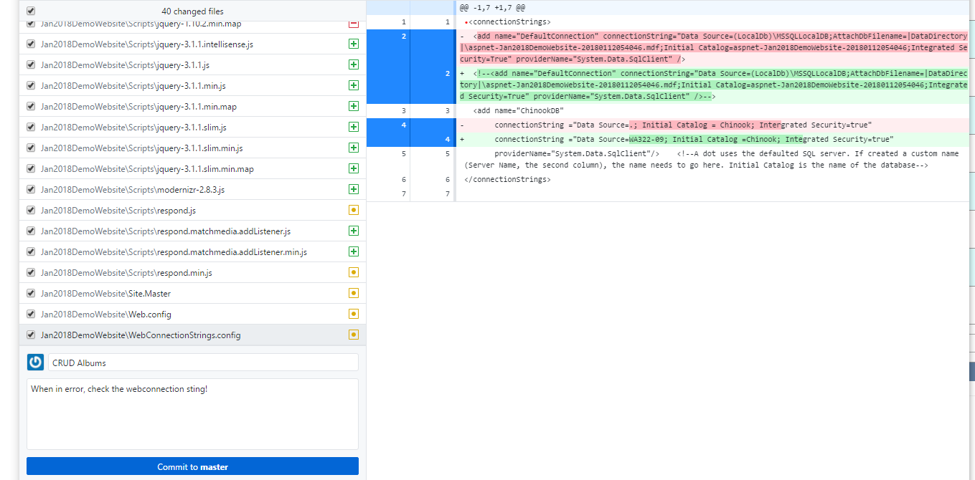

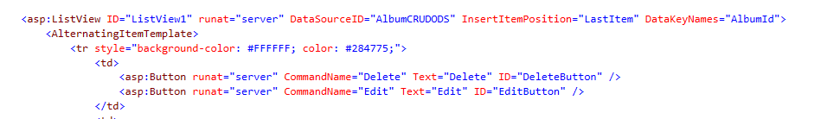

**This means you have alterating color**

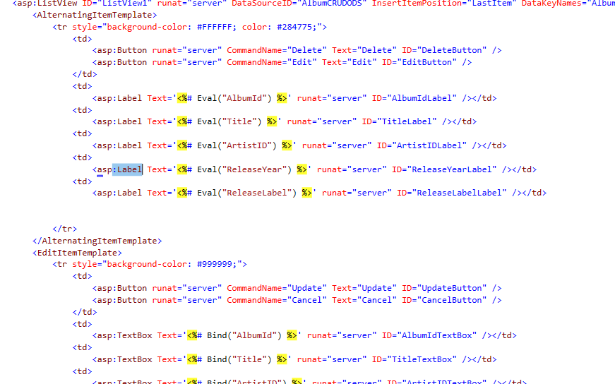**Edit template vs display template. Label vs textbox**

**Eval is a one way trip, read-only.**

**Bind is two-ways.**

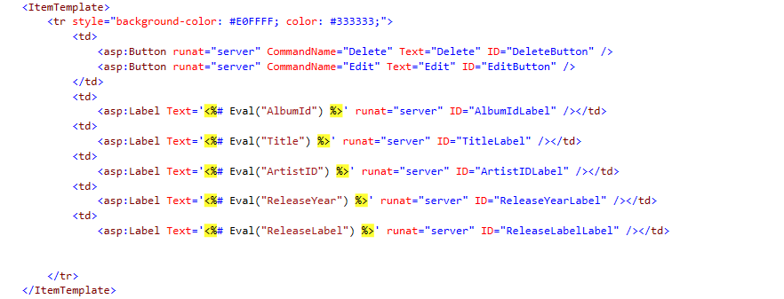

**This is very important, defines what the table looks like.?**

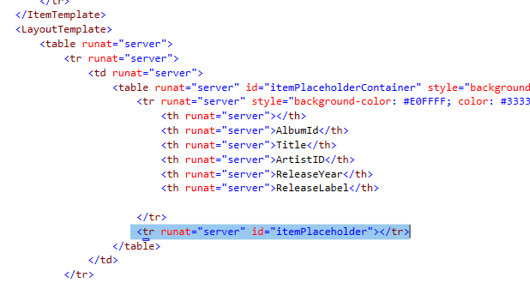

**<th> is a type of lable. Therefore no need to specify the width.**

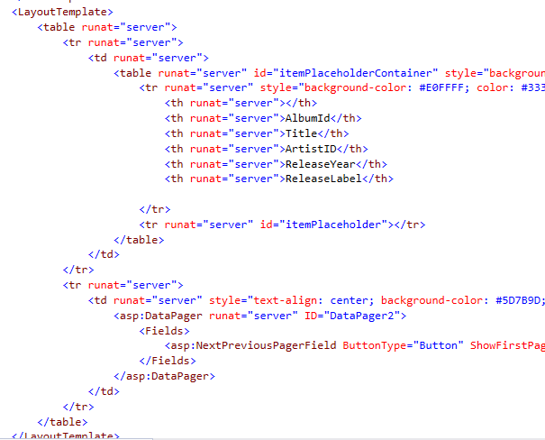

**One must have an item template and a layout template**

**The first one is the buttons.** 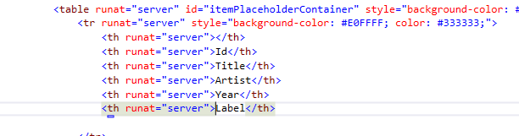

**A label auto expand to fit the size of data. Therefore not really need the width here.**

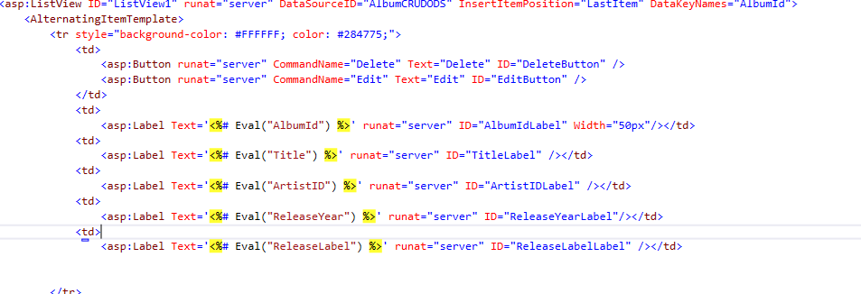

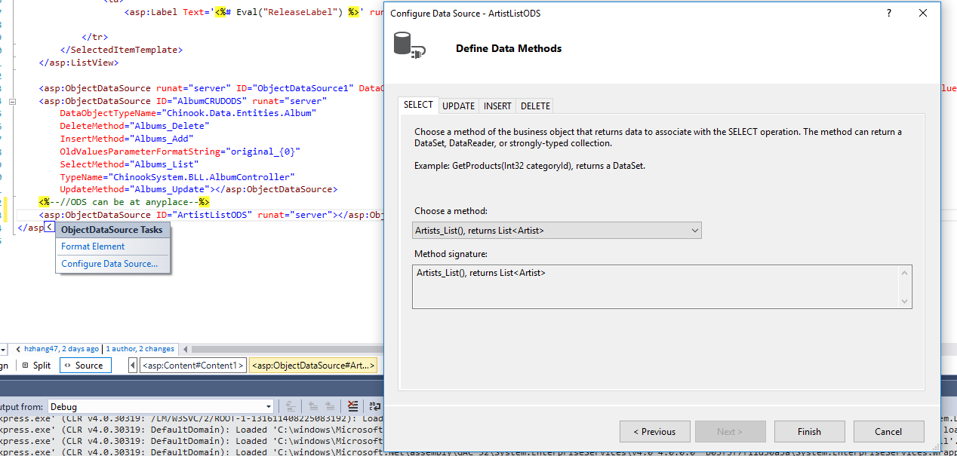

**ODS DDL don’t need CRUD.**

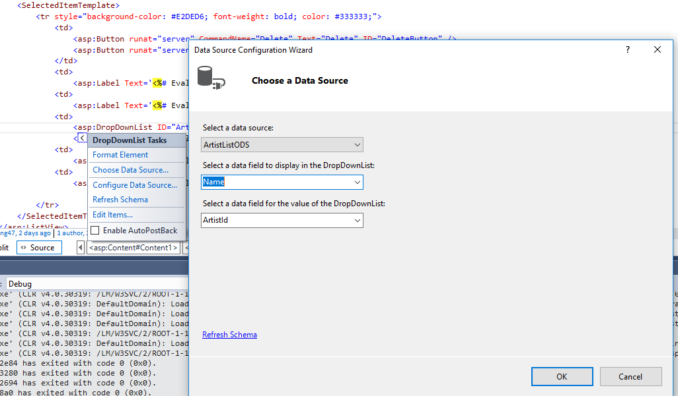

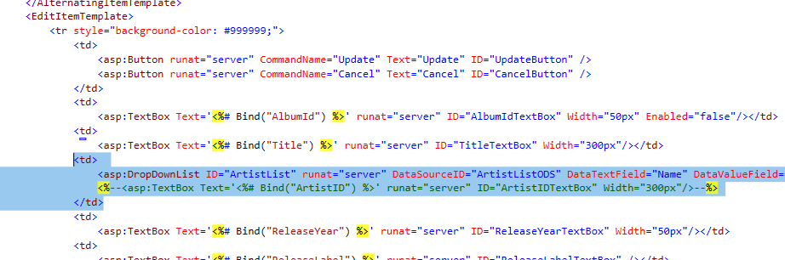

**Watch out of the td tag.**

**Edit and input change eval to bind**

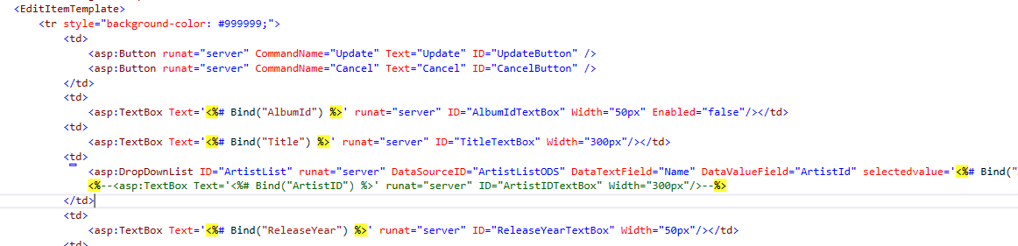

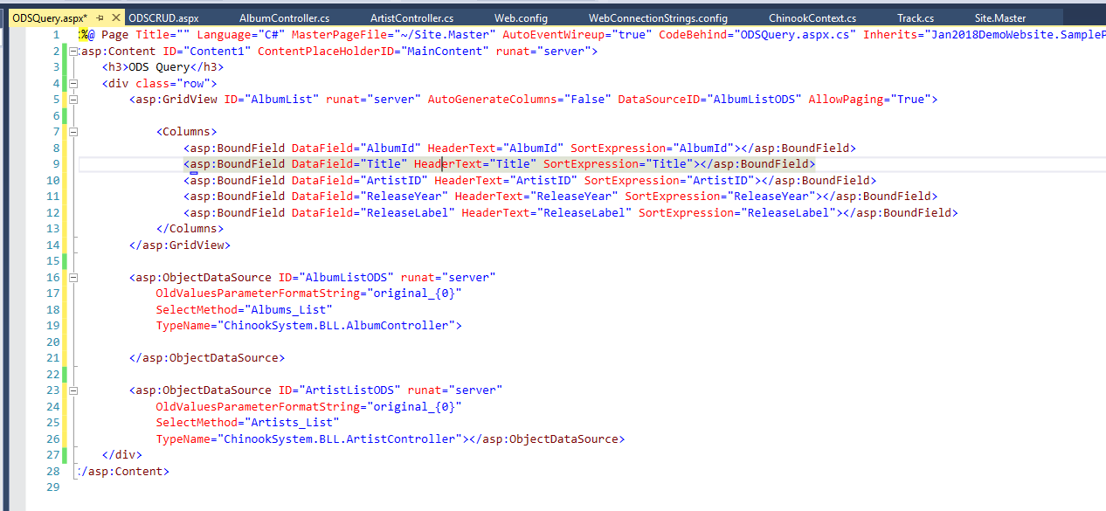

**Convert all fileds to a template**

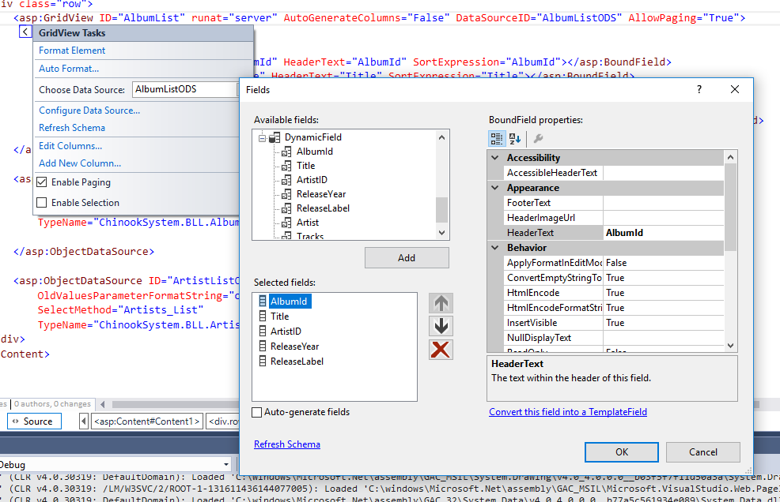

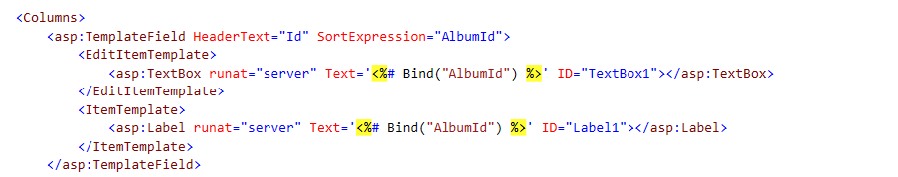

**Look at the names of the template filed, because this is read only, therefore don’t need the edititemtemplate.**

**Add Commandfield -> Select**

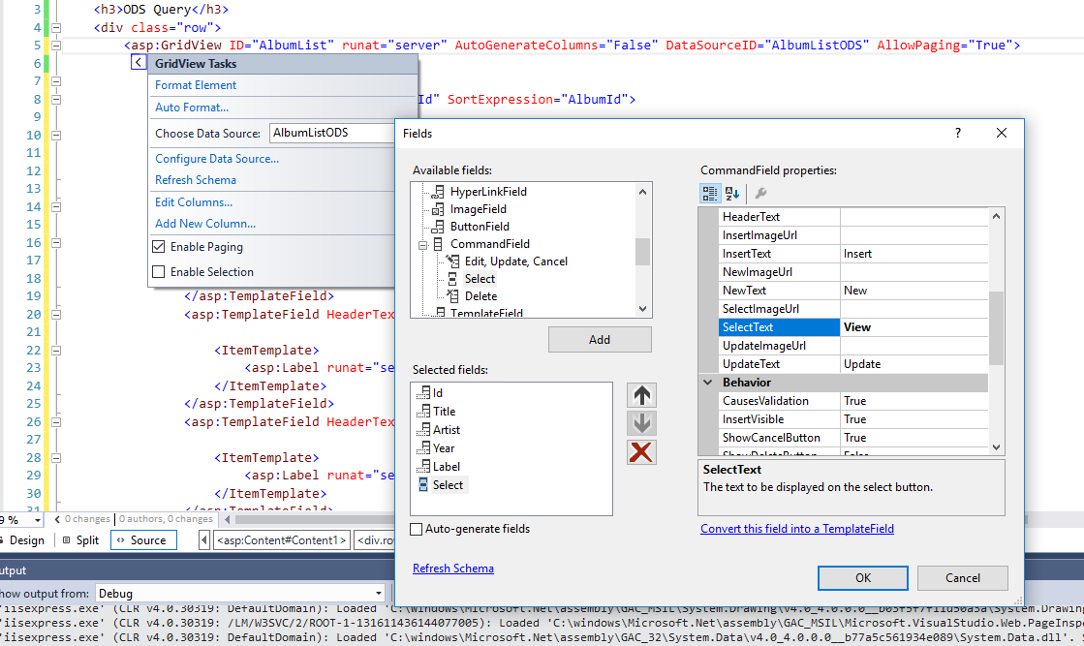

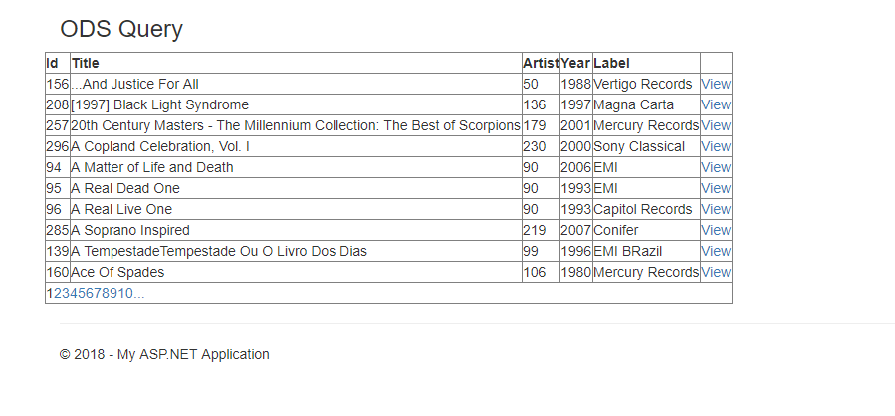

**Use .FindControl() <=”Name of the control on your grid view or ListView” (the ID, the “label1”)**

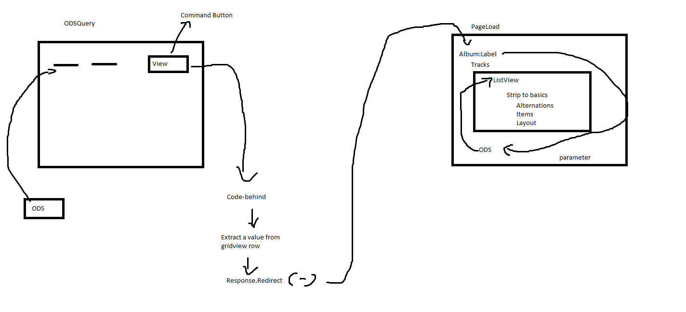

**IMPORTANT! Here need to make sure the ID MATCHES!!!**

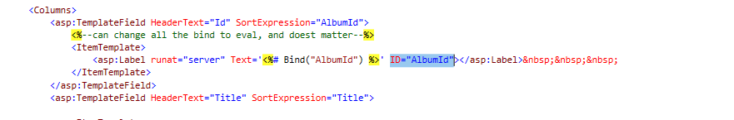

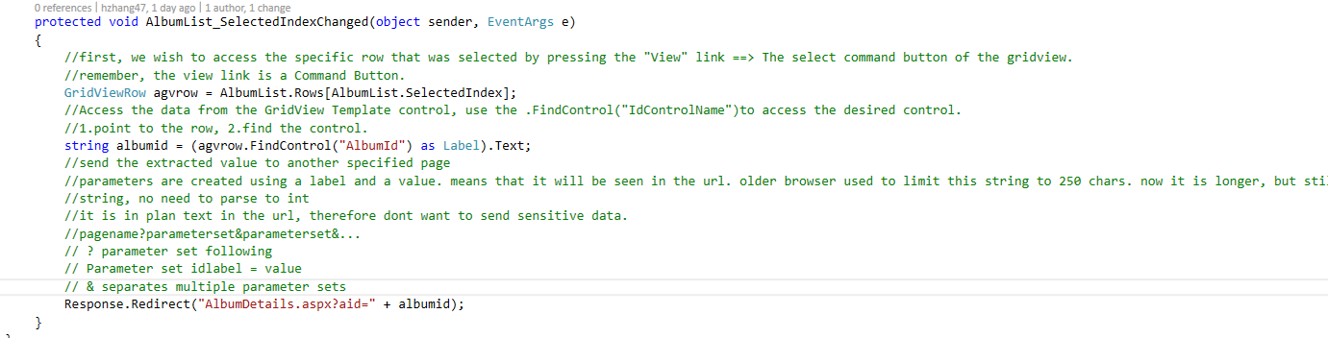

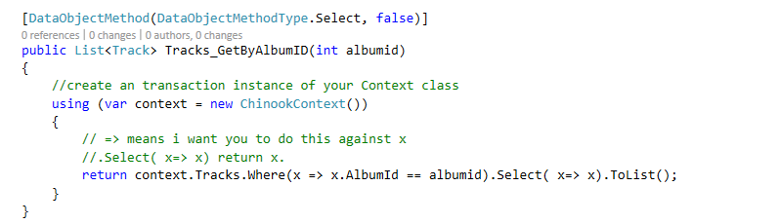

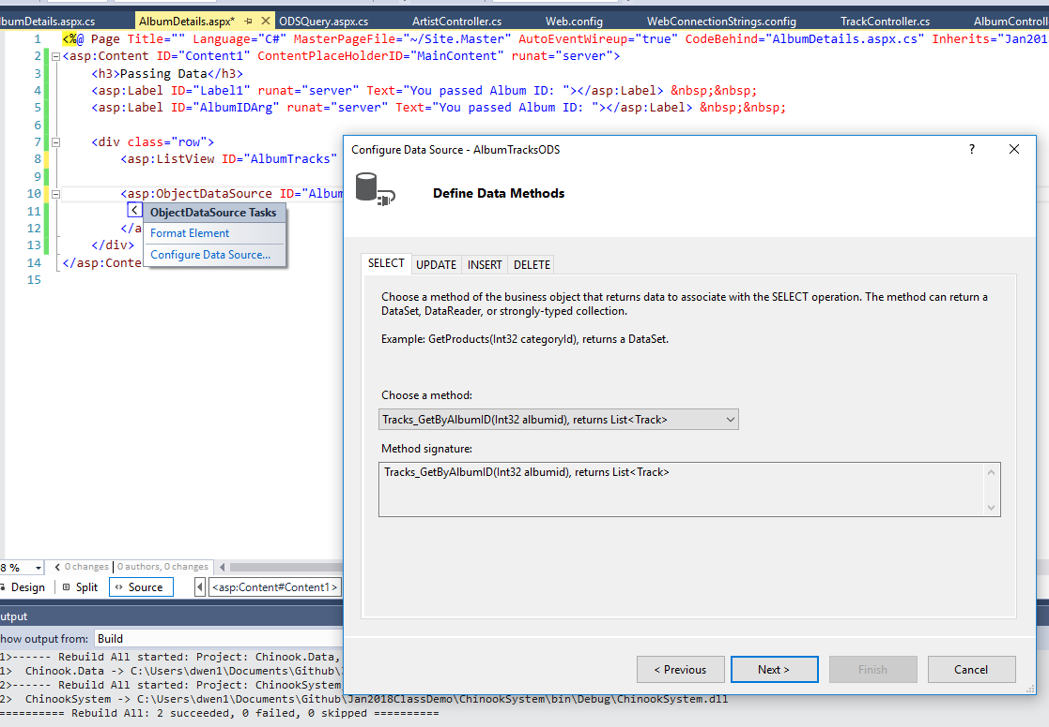

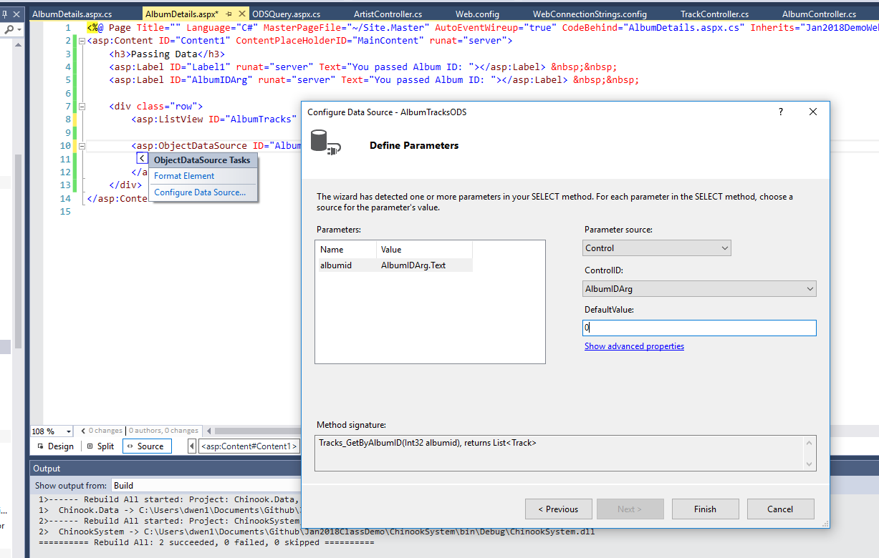

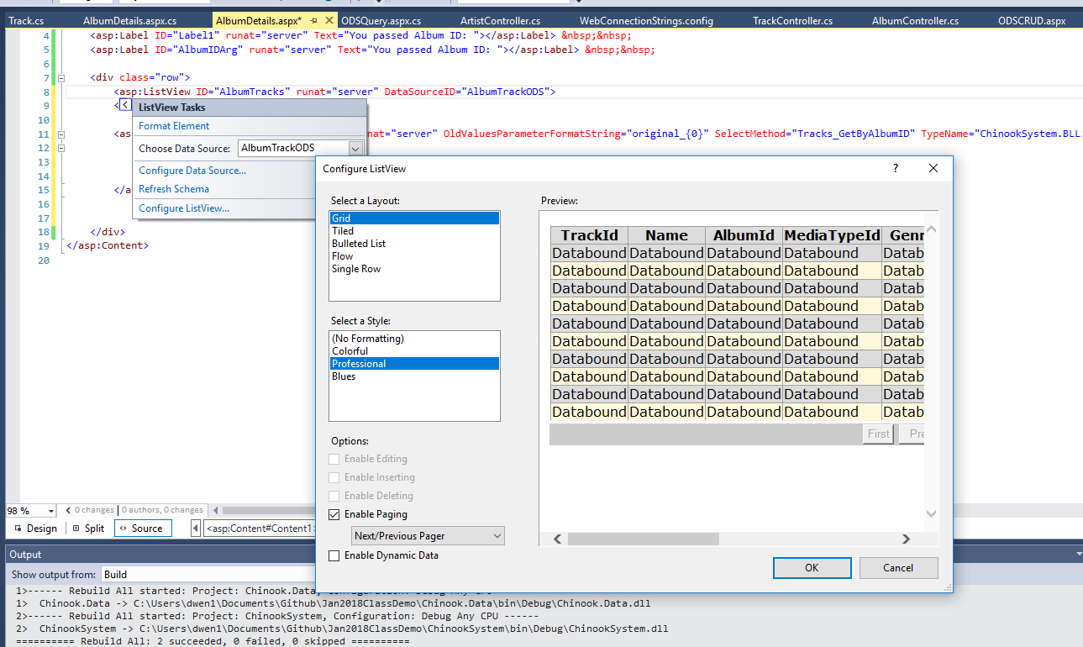

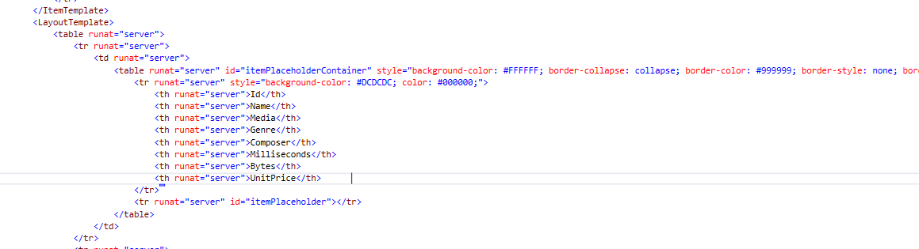

**Layout identify the structure of the column…**



**If you have runat server on anything controls, than all must have it.**

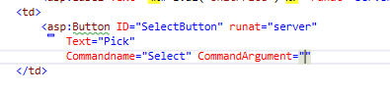

**Use command argument to hold a piece of data. Eg no one should know what your database pk is.**

**So copy pk.**

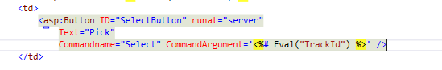

**Don’t wanna do it on a CRUD, but on a QUERY, usually need to remove the PK**

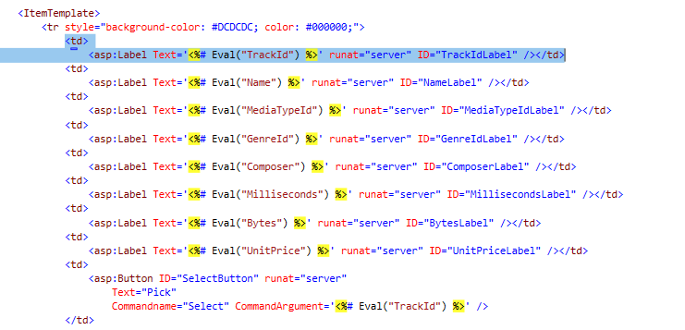

**Copy this to the Alternation item temp**

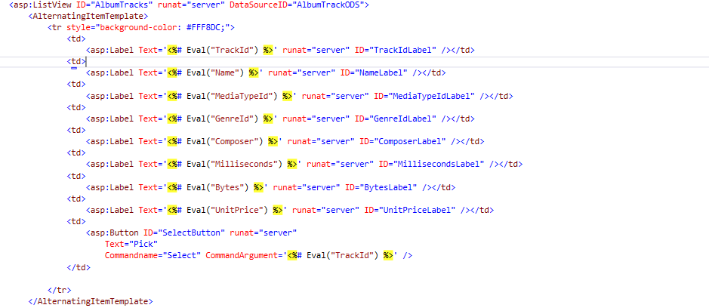

**Lastly , need this “onclick” command**

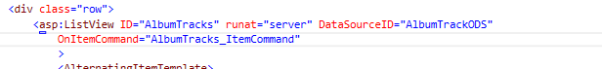

**Step 2:**

**First, be lazy…**

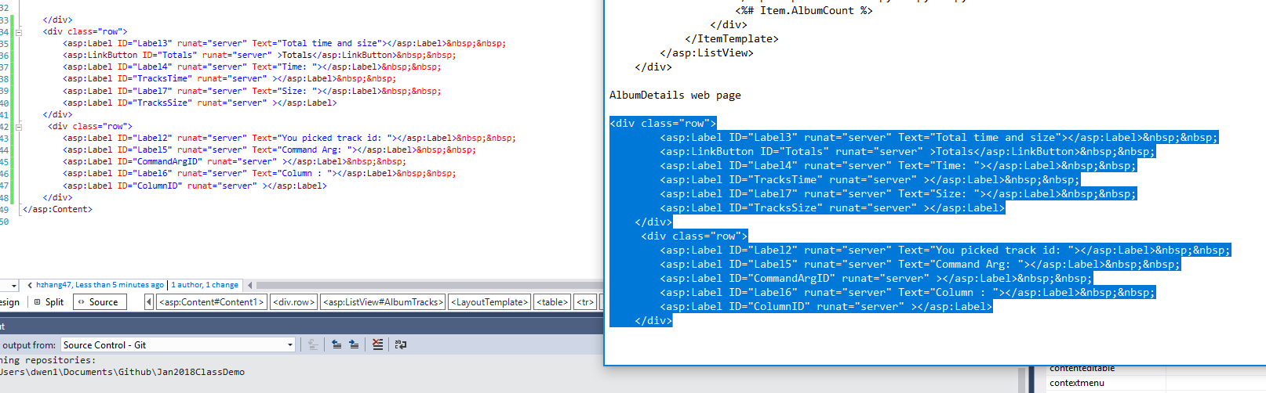

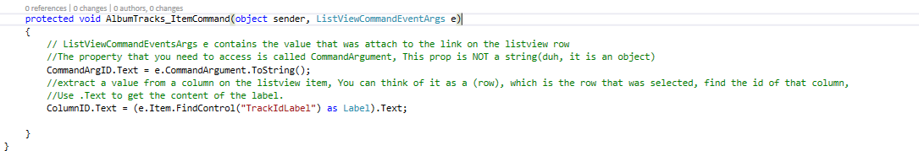

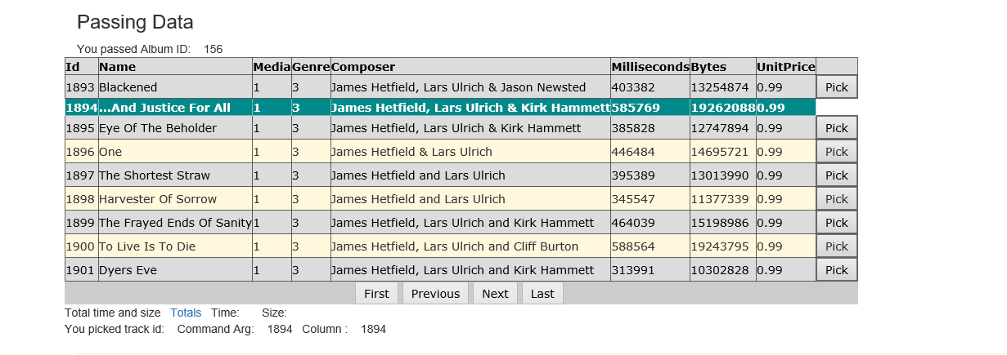

**Notice the ids are the same, we can hide the id and put that under the button.**

**Next, we will travers every records in the display. Access a column of a row**

**Double click this**

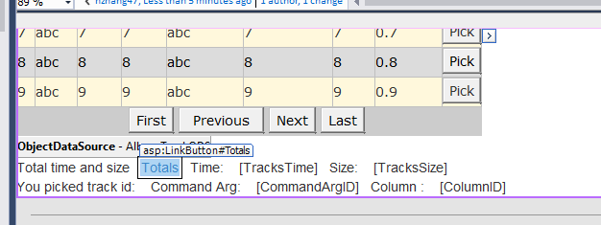

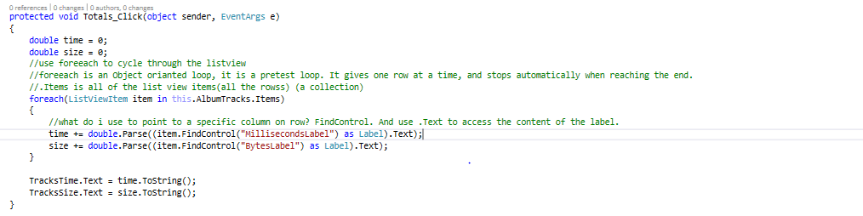

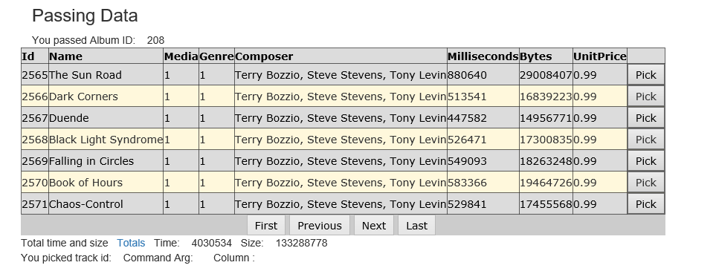

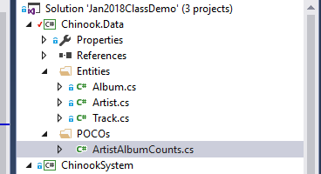

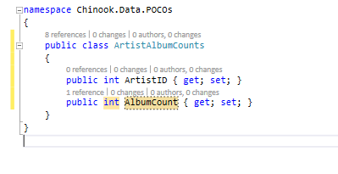

**Datatype that am gona use in my list view.**

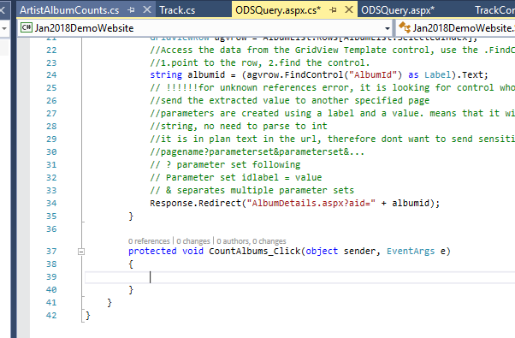

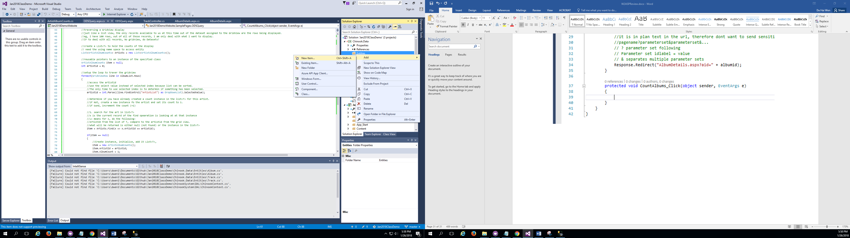

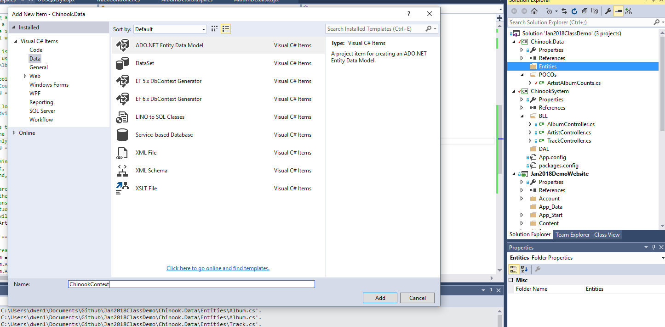

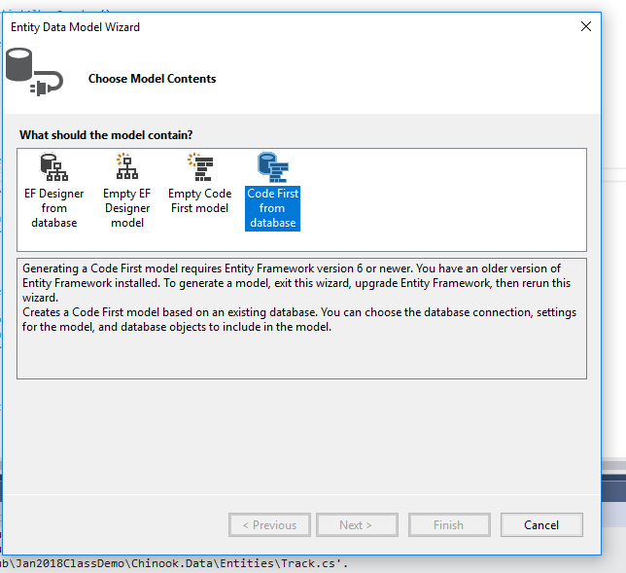

**Solve by installing this:**

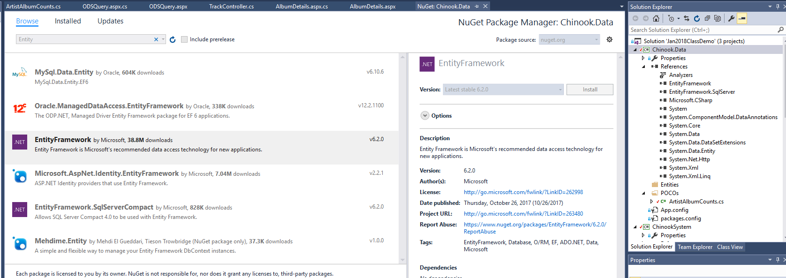

**If there is no connection string here, create a new one.**

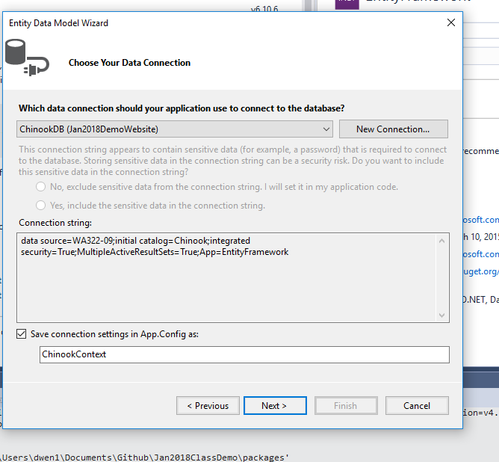

**Change the bootom to your connection string name!**

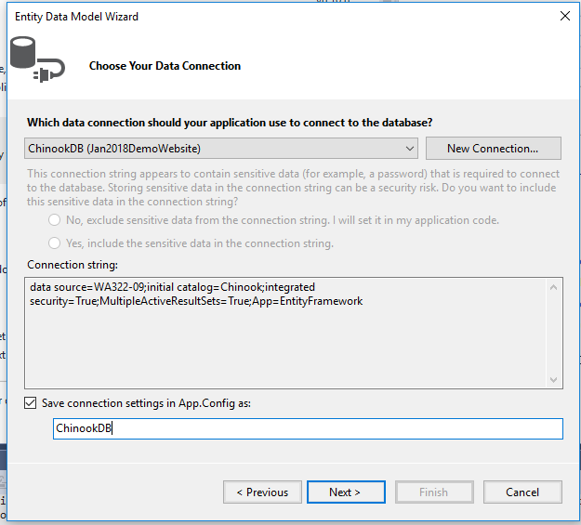

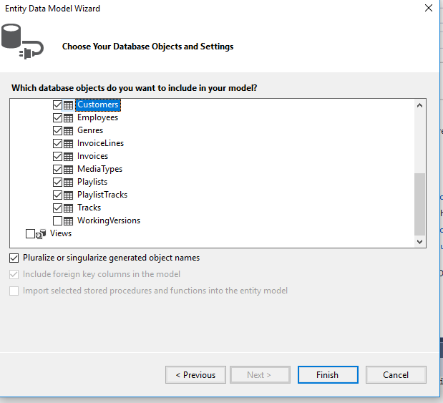

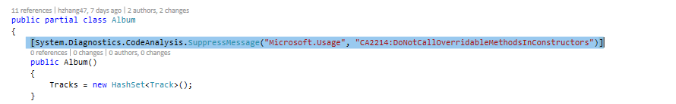

**Don’t touch the diagnostic yet.**

**Still need to put in customized error messages.**

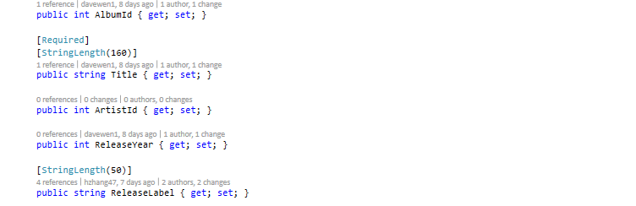

**The navigational has already pointed to the child.**



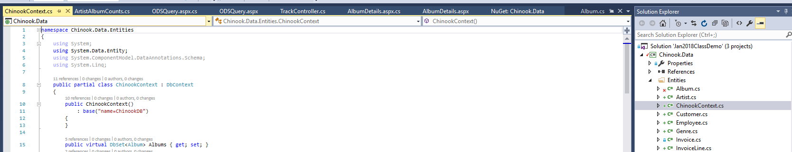

**Move the context class into the DAL**



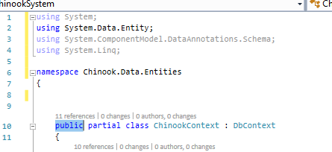

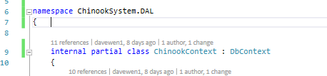

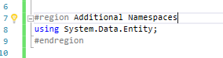

**Ignore these for the time being**

